Title
Name Surname¹ and Name Surname²

¹ Address
² Address
Corresponding author’s email

ISABC-16 – Ioannina, June 11th-14th 2023, ISABC-16 – Ioannina, June 11th-14th 2023, ISABC-16 – Ioannina, June 11th-14th 2023, ISABC-16 – Ioannina, June 11th-14th 2023, ISABC-16 – Ioannina, June 11th-14th 2023,
(Abstracts (including titles, names, address and the full text) should not exceed one A4 page in total, using fonts Times New Roman, single space and default margins (top 2.54 cm, below 2.54 cm, left 3.18 cm right 3.18 cm))

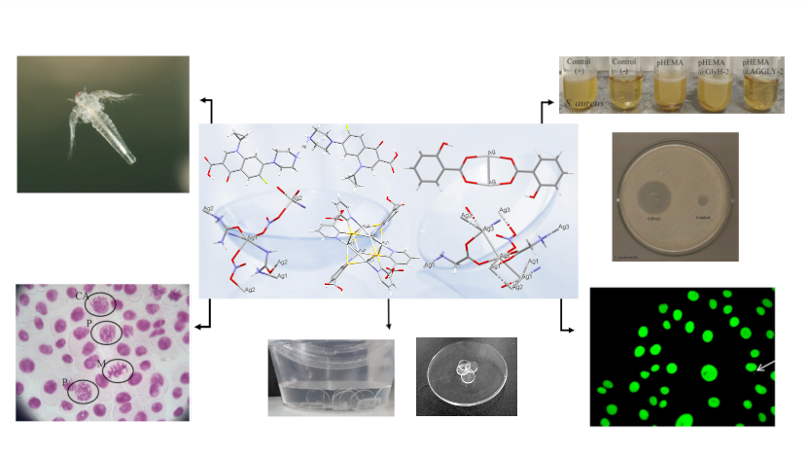
Acknowledgements

References
[1]

